1st Bugle

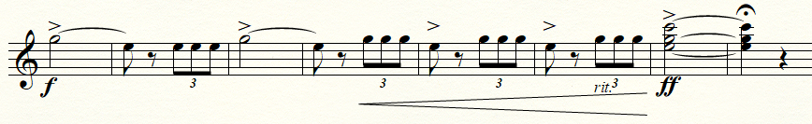
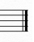

2nd Bugle

